**LAB # 12**

**Task # 1: Train the Artificial Neural Network using the dataset provided in the lab.**

**Solution:**

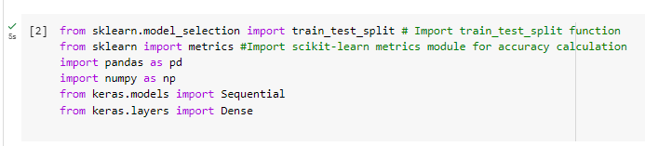

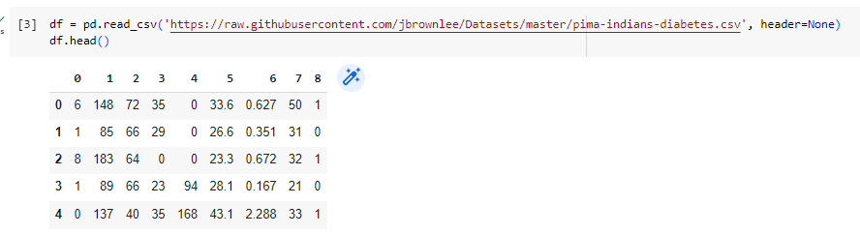

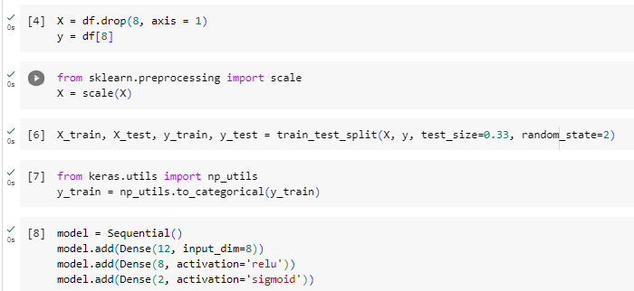

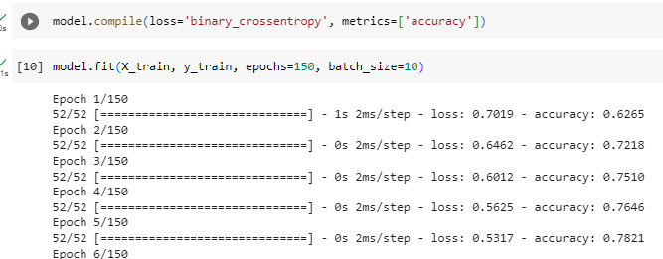

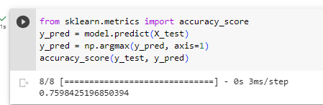

**Task # 2: Train the Artificial Neural Network using the iris dataset and discussed the results.**

**Solution:**

